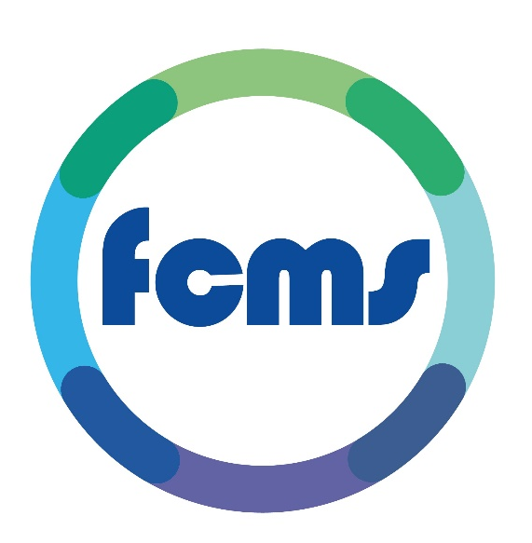

Annual Report 2024/25

Contents Page

Item Page
The front page 1
Contents page 2
Introduction 3
Who is FCMS 3
Our Values 4
Commitment 4
The Equality Act 5
Our Goals 6
Governance & Assurance 6
Our Workforce 7
Recruitment & Selection 8
Training 9
Achievements 10
Patient Experience 10
Patient Feedback 10

Introduction
Our journey to embed Equality & Diversity allows us to make every effort to eliminate discrimination, create equal opportunities and develop good working relationships between a range of diverse communities.
This Annual Report focusses on Equality and will seek to look at information from our organisation, including our employees and the services we provide to patients.
We look to meet the statutory duties under the Equality Act 2010, inclusive of this Annual Equality Report.

Who is FCMS?
FCMS is a Social Enterprise health and wellbeing services provider and we are passionate in our drive to deliver exceptional care to our patients, who are the central focus of all that we do.
Our Why? To nurture an environment of inspiration, innovation and disruption so that the people within our world receive exceptional care for this generation and the next!
Over many years we have invested in our staff so that we have a core team of highly trained individuals who can manage the needs of our patients and callers. Our staff are able to significantly improve the service delivery and user experience due to their considerable experience and commitment to what they do.

Our Values
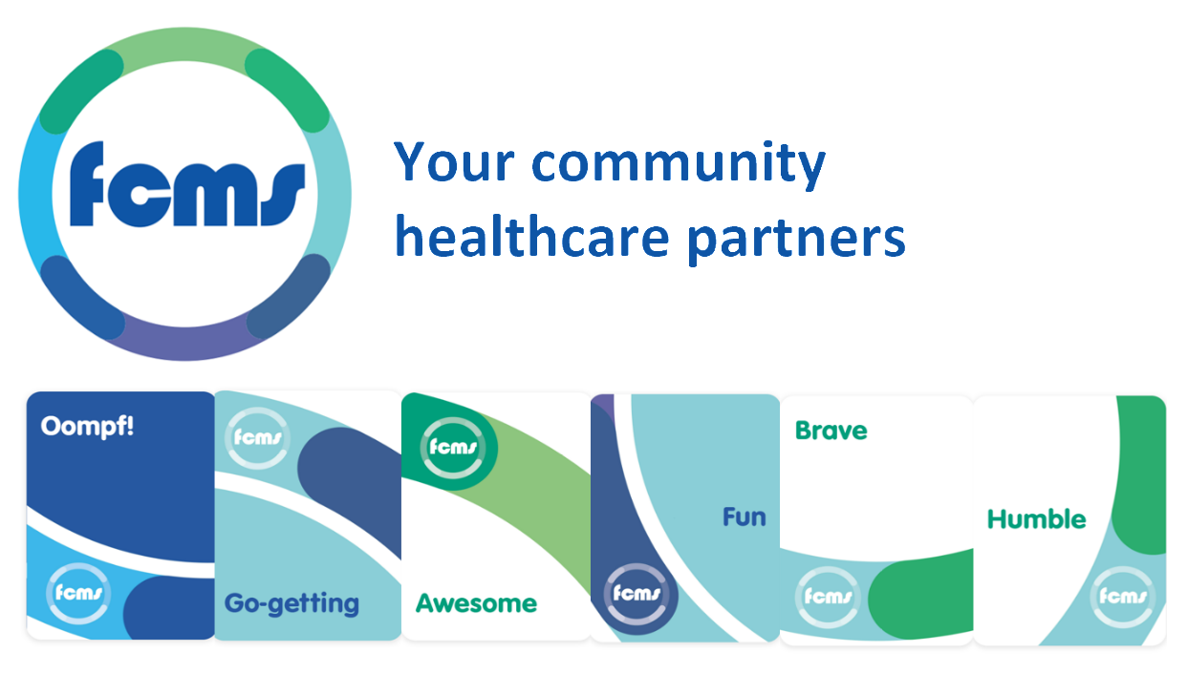

Our commitment
FCMS is committed to providing equal opportunities in employment and to avoiding unlawful discrimination in its employment or to customers. FCMS believes that the promotion of Equal Opportunity is a key component of good management as well as being legally required, socially desirable and morally right. Striving to ensure that the work environment is free of harassment and bullying and that everyone is treated with dignity and respect is an important aspect of ensuring equal opportunities in employment.
Fairness in the workplace is a vital part of a successful business. The Equality Act 2010 supports this. This Act aims to improve equal job opportunities and fairness for employees and job applicants.

The Equality Act
In the Equality Act 2010 legislation, nine areas are termed as protected characteristics.

Age Race
Disability Sex
Gender reassignment Sexual orientation
Marriage and civil partnership Religion or belief
Pregnancy and maternity

The Equality Act became law in October, 2010. It replaced previous legislation (such as the Race Relations Act 1976 and the Disability Discrimination Act 1995) and ensures consistency in what employers and employees need to do to make their workplaces a fair environment and comply with the law

Employers and employees in the public sector, and in private or voluntary organisations carrying out work on behalf of a public sector employer, have a legal public sector equality duty in the workplace to prevent and eliminate discrimination, establish and promote equality and equal opportunities, and foster good relations between people with different protected characteristics.
The Equality Duty has three aims. It requires public bodies to have due regard to the need to:
- eliminate unlawful discrimination, harassment, victimisation and any other conduct prohibited by the Act;
- advance equality of opportunity between people who share a protected characteristic and people who do not share it; and
- Foster good relations between people who share a protected characteristic and people who do not share it.
Having due regard, means consciously thinking about the three aims of the Equality Duty as part of the process of decision-making. This means that consideration of equality issues must influence the decisions reached - such as in how they act as employers; how they develop, evaluate and review policy; how they design, deliver and evaluate services, and how they commission and procure from others

Our Goals

- Collate the representative data at Induction stage and use the Self service Rotamaster Equality tab for the most accurate representation.

- Continue to promote Equality and Diversity awareness within all FCMS policy and procedures and as part of our culture work.

- Actively engage in the Equality and Diversity national calendar and increase education around the 9 characteristics.

- Consider the ways we can utilise our own internal calendars to be able to bring people into awareness and promote better conversations.

- Improve Recruitment processes to ensure fairness for all.

Governance & Assurance

Within the organisation we have a number of established committees, such as the Board of Directors, Leadership team, Senior team, Clinical Governance and others. These groups do play a vital role in leading and monitoring equality. All aspects of patient experience and clinical policies are reviewed and approved at the relevant clinical governance groups. Other policies are reviewed regularly and updated when necessary in line with new legislation and the results of any Equality Impact Assessments.
The managers of our teams have a responsibility to ensure that equal opportunities are promoted and sustained through training and progression. All staff have access to the policies and procedures that support a safe and inclusive work environment.
A number of these policies are:
- Recruitment & Selection Policy
- Sexual Harassment Policy – adopted October 2024
- Paid and unpaid leave policy
- Flexible working Policy
- Bullying and Harassment
- Maternity & Paternity leave
- Appearance Policy
- Whistleblowing Policy

Our Workforce
As an organisation we are fully committed to equality, diversity and inclusion and to create a safe and inclusive working environment where people from all sectors of the community can come to work and be provided with the support and development required so that they can reach their full potential.
There is a statutory requirement for public bodies with greater than 150 employees to publish a workforce profile.
As an organisation we look to provide the best working environment for our staff in order for them to deliver a quality service to the patients and carers they serve. It is vital that we are able to identify our priorities in partnership with our local stakeholders, staff, services users and carers.
Workforce information will be reviewed internally through the senior management team and key recommendations will be developed to improve any areas of under-representation.
Our workforce data shows representatives of each of the characteristics as below:
Total number of employees at the start of the period = 823 | 01 April 2024 – 30 March 2025
Protected Characteristic
Age | 16 – 24 9.84%  25 – 34 22.98%  35 – 44 23.08%  45 – 54 20.17%  55 – 64 19.68%  65 – 74 4.13 %  75 – 85 - 0.12%
Gender | Male – 23.08%  Female – 76.68%  Non Binary 0.24%
Disability | No 74.9%  Yes 17.3%  Prefer not to say 7.8%
Ethnicity | White 87.32%  Black 1.83%  Asian 6.9%  Bi-Racial 1.9%  Other / prefer not to say 2.05%
Religious belief | Christian 34.1%  Hindu 0.7%  Muslim 4.1%  No Religion or belief 32.1%  Prefer not to say 25.6%  Other 3.4%
Marriage/Civil Partnerships | Married/ Civil Partnership 35.96%  Single 42.28%  Living with Partner 19.7%  Prefer not to say 2.06%
Sexual Orientation | Heterosexual 91.37%  Prefer not to say 2.67%  Gay & Lesbian 3.4%  Other 1.3%  Bi sexual 1.26%

Recruitment & Selection
The Company aims to attract and appoint the most suitable candidate for each of its vacancies. This means that decisions regarding short listing and appointment need to be taken without reference to a candidate's race, sex, religion, accent, age, sexual orientation, caring responsibilities, trade union activities or other variants which are irrelevant to a candidate’s suitability for the post.

The Company undertakes to interview all applicants who meet the minimum criteria for a job vacancy and consider them on their abilities. Careful consideration will be given to any candidate with a disability in accordance within the Equality Act 2010 in reference to the DDA Act 1995. This requires consideration to be given to any 'reasonable adjustment' that could be made which would allow the person to undertake the post. Applicants will not be precluded from employment on the grounds that arrangements may be required because of their disability to enable them to fulfil their role. Managers must give full consideration to making reasonable adjustments to the job or to the working environment during the recruitment process.

We have recently been awarded the Disability Confident Chartermark.

Training
All staff undertake Equality and Diversity training as part of their induction and then every two years. For much of our workforce in the out of hours service, their employment is often a second job by necessity working hours are outside of normal office hours. This can present challenges in delivering training, therefore we rely heavily on online training which can be completed at times to suit the individual.

We deliver a Leadership Development Programme that supports our desire to have managers that lead with compassion and care. As a wellbeing employer our focus is on Self Awareness, Coaching for Conversations, Mind Gym – to understand mental health complexities and how we can have better conversations with each other.
Our Mandatory training continues to progress and the Training team have been determined to improve figures.
FCMS Achievements
The Clinical structure has been a priority this year. Ensuring that we have the right roles to deliver the best care started last year when we appointed a local GP with a Primary care background to the Board of Directors. We have introduced a Salaried GP model that offers some more stability in patient care and their role is to support a GP role with our services alongside governance and training. This supports the robust clinical structure.
We have continued to invest in our support functions, including People & Wellbeing, Finance and our Futures team to ensure our on the ground service delivery teams are well supported.
We have ensured that our senior structure is set for the future with a change in role of the Chief Operating Officer, Lee McGlynn to Chief Futurist and Deputy CEO. Sam Marsh, who was our Director of Quality & Risk now takes the position of Chief Operating Officer. To streamline support for our teams and create space for growth is a great opportunity.
Between April and June 2024 we made a commitment to ensuring that we were taking advantage of the roles within our business. We dedicated a restructure to making two new business units, a Place based and Virtual business unit. This has altered the team in management roles and is a concerted effort to make sure that we use the skills we have across the organisation.

Patient Experience
The organisation has an obligation under the Equality Act 2010 to ensure equal access to our services. Our model of service delivery allows patients to have a variety of options to access the services from telephone advice, to home visits and 24 hour accessibility. We continually strive to make the patient journey the best experience it can be.
When patient demographics are taken we take information that is vital to care, and also diversity information that does not pry. For example; Age, Gender, Ethnicity, whether the patient has a disability and, on some occasions, Religion or belief (where it is relevant to care).
To help our patients access our services we have adapted a range of adjustments. Our letters are translated into 5 different languages for those who do not have English as their first language. We also access hearing loop, language line for telephone calls, and have wheelchair access at our sites.

We are conscious to ensure where patients have planned appointments that they are aware if their clinician is male or female. This is important for people’s religious beliefs.

Patient Feedback
To ensure we continually improve our patient journey within all of our services we gain as much patient feedback as possible. To gather this feedback we use, Patient Questionnaires, Friends and Family tests and I Want Great Care. Some diversity information is requested from these questionnaires, but only relevant data and not from all of the 9 characteristics.
Patient feedback can also be completed by carers and gives all patient and carers a voice to highlight any issues with their accessibility or Equality and Diversity needs. Currently we have not received any feedback that we have needed to adjust our practices for in terms of diversity and accessibility, but if issues were highlighted FCMS would work hard to find the right solution and improve the patient experience.

