

Reference: FCMS/PRO/146  Author: Head of Clinical Governance  Validation Date: 31/07/2025  Review Date: 31/07/2028 | SOP for the Patient Safety Incident Response Plan (PSIRP)

Amendment/Version History
Version Number: | Date: | Details of Change Made: | Amendment made by (name and role):
1 | Nov 23 | New Procedure | Carrie Cobb
2 | March 25 | Review and Amendment following ICB engagement | Emily Taylor, Head of Clinical Governance
3 | July 25 | Final amendments following trials of learning response methods prior to formal ratification | Emily Taylor, Head of Clinical Governance

Consultation and Ratification
Version Number: | Date: | Person/s and/or Groups consulted during production (name and role): | Committee Ratified by:
1 | Nov 23 | Suzy Layton, CEO. Samantha Marsh, COO. | N/A
2 | March 25 | Clinical Leadership Team | N/A
3 | 31 July 25 | Patient Safety Group, Senior Quality Review, Leadership Team. | Patient Safety Group and Leadership Group

Table of Contents
Introduction 4
National PSIRF Training requirements 5
Our services 5
Defining our patient safety incident profile 6
National Requirements 6
Learn from patient safety events (LFPSE) 8
Learning Responses available include: 9
Patient Safety Incident Investigation (PSII) 9
After-Action Review 9
PSIRF Multidisciplinary Team (MDT) Review 9
Swarm Huddles 10
Responding to cross system incidents / Issues 10
Patient Safety Group 10
Timeframes for learning responses 11
Safety Action Monitoring 11
Distribution and communication plan 12
To be disseminated to: 12
References and Further Reading 12
Appendix 1 – Governance Structure 13

Introduction
This document is the Patient Safety Incident Response Plan (PSIRP) and it sets out how FCMS intends to respond to patient safety events over a period of 12 months. This includes the learning response methods to be applied and rationale. The plan is not a permanent rule that cannot be changed. We will remain flexible and consider the specific circumstances in which patient safety issues and events occur and the needs of those affected.
The plan describes how we defined our patient safety incident profile and how we identified and agreed our local priorities.
One of the underpinning principles of PSIRF is not to do fewer ‘investigations’, but to do them better. This means taking the time to conduct system-based investigations by people that have been trained to do them. This plan and associated policy will describe how it will work.
A rigorous planning exercise will be undertaken every four years and more frequently if appropriate (as agreed with our integrated care board (ICB)) to ensure efforts continue to be balanced between learning and improvement. This more in-depth review will include reviewing our response capacity, mapping our services, a wide review of organisational data (for example, patient safety incident investigation (PSII) reports, improvement plans, complaints, claims, staff survey results, inequalities data, and reporting data) and wider stakeholder engagement.
Training is in place via the HSSIB website as new modules are added and identification of central and local roles clarification is being determined. This will be In line with the below in regard to what roles will need what level of training over the next 6 months. Attendance at the PSIRF webinars via the NHS futures platform are also ongoing. Our engagement leads with be our local governance leads and clinical managers. Learning response leads will be either clinical or operational managers dependent on the nature of the incident. The Head of Clinical Governance will take on the role of PSIRF Implementation Lead.

National PSIRF Training requirements

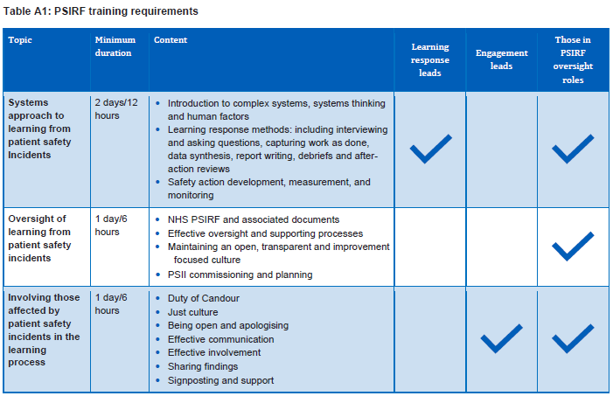

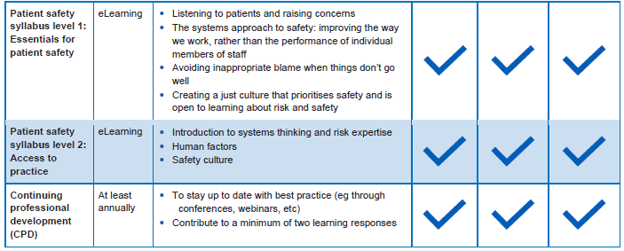

Our services

Our services at FCMS cover a wide range including but not limited to:
- Urgent care
- Out of Hours and Enhanced Access Care
- 111
- Dental
- Diagnostics
- Inclusion Health
- Health Checks

Defining our patient safety incident profile

Following a review of Ulysses incidents reported, and engagement with the local teams, wider senior leadership team, and patient feedback we identified three patient safety themes to focus on:

Patient Safety Incident Type or Issue | Planned Response | Anticipated Improvement Route
Delays in Identifying or Reporting Safeguarding Concerns | PSIRF Multidisciplinary Team Meeting | Identify systems engineering contributions as learning outcomes, to create local organisational actions and feed these into the quality improvement strategy
Incidents concerning the administering, prescribing or storage of Controlled Drugs | PSIRF Multidisciplinary Team Meeting | Identify systems engineering contributions as learning outcomes, to create local organisational actions and feed these into the quality improvement strategy
Patient Safety Incidents that occur due to a breach of agreed service level agreement timescales within the Clinical Assessment Service | PSIRF Multidisciplinary Team Meeting | Identify systems engineering contributions as learning outcomes, to create local organisational actions and feed these into the quality improvement strategy

National Requirements

Patient safety incident type | Required response | Anticipated improvement route
Incidents meeting the Never Events criteria | PSII | Create local organisational actions and feed these into the quality improvement strategy
Deaths  - thought more likely than not due to problems in care (incident meeting the learning from deaths criteria for patient safety incident investigations (PSIIs)  - Deaths of patients detained under the Mental Health Act (1983) or where the Mental Capacity Act (2005) applies, where there is reason to think that the death may be linked to problems in care (incidents meeting the learning from deaths criteria)  - Child deaths  - Deaths of persons with learning disabilities  - Deaths in custody (eg police custody, in prison, etc) where health provision is delivered by the NHS | - PSII  - PSII  - Refer for Child Death Overview Panel review.  - Locally-led PSII may be required alongside panel review.  - Refer for Learning Disability Mortality Review (LeDeR)  - Locally-led PSII (or other response) may be required alongside the  - LeDeR – organisations should liaise with this  - Any death in prison or police custody will be referred (by the relevant organisation) to the Prison and Probation Ombudsman (PPO) or the Independent Office for Police Conduct (IOPC) to carry out the relevant investigations  - Healthcare organisations must fully support these investigations where  required to do so | Create local organisational actions and feed these into the quality improvement strategy  Respond to recommendations as required and feed actions into the quality improvement strategy
Incident meeting Each Baby Counts criteria | Referred to Healthcare Safety Investigation Branch for independent patient safety incident investigation | Respond to recommendations as required and feed actions into the quality improvement strategy
Mental health-related homicides | Referred to the NHS England Regional Independent Investigation Team (RIIT) for consideration for an independent PSII  Locally-led PSII may be required | Respond to recommendations as required and feed actions into the quality improvement strategy
Domestic homicide | A domestic homicide is identified by the police usually in partnership with the community safety partnership (CSP) with whom the overall responsibility lies for establishing a review of the case | Respond to recommendations as required and feed actions into the quality improvement strategy
Safeguarding Incidents | Refer to local authority safeguarding lead  We must contribute towards domestic independent inquiries, joint targeted area inspections, child safeguarding practice reviews, domestic homicide reviews and any other safeguarding reviews (and inquiries) as required to do so by the local safeguarding partnership (for children) and local safeguarding adults board | Learning to be actioned across the organisation.

Learn from patient safety events (LFPSE)
To ensure that FCMS is compliant with the NHS England Learn from patient safety events (LFPSE) requirements, all incidents rendered as a Patient Safety Incident will be reported to the LFPSE service, via the relevant module hosted by our Local Risk Management System (LRMS). By adopting this practice, FCMS will be able to contribute to a national NHS wide data source, to support learning and development, and will be able to access data submissions to allow us to better understand our local reporting practices and culture.

Learning Responses available include:

Patient Safety Incident Investigation (PSII)

A Patient Safety Incident Investigation (PSII) is a comprehensive investigation which will utilise the System Engineering Initiative for Patient Safety (SEIPS) framework. These investigations may be initiated when it is felt a patient safety event meets the criteria to be defined as a national or local priority.

After-Action Review

An After-Action Review is a method of evaluation that is used when outcomes of an activity or event, have been particularly successful or unsuccessful. It aims to capture learning from these tasks to avoid failure and promote success for the future.
It is important to try and include as many people as possible who were involved in the activity or event so that a wide range of viewpoints can be explored. Everyone should feel they are able to contribute without fear of blame or retribution. After Action Reviews are about learning, not holding people to account. The discussions tend to last a maximum of one hour.
The facilitator of the group will guide the group through a series of appreciative enquiry questions, but will aim to answer the following 4 key questions:
- What did we expect to happen?
- What actually happened?
- What are the differences between what was expected, and what was done?
- Should the outcomes be avoided or aimed for in the future, why and how?

The convened group will then agree any appropriate actions and identified learning.

PSIRF Multidisciplinary Team (MDT) Review

The multidisciplinary team (MDT) review supports health and social care teams to:
• Identify learning from multiple patient safety incidents
• Agree the key contributory factors and system gaps in patient safety incidents
• Explore a particular safety theme
• Explore a pathway, or process
• Gain insight into ‘work as done’ in a health and social care system

Multidisciplinary (MDT) Team Reviews are most useful when a wide range of stakeholders share their perspective on ‘work as done’ in the health or social care system being analysed.

Swarm Huddles
A learning response method that is utilised for serious patient safety events, and should occur immediately after an incident. Staff ‘swarm’ to the site to quickly analyse what happened and how it happened and decide what needs to be done to reduce risk.
Swarm Huddles are helpful to:
- Gain insight into what happened and people’s recollections quickly;
- Plan what needs to happen to reduce immediate risk; and
- Check on the welfare of staff members affected by the incident.

Responding to cross system incidents / Issues

FCMS is committed to taking a system wide approach to learning from patient safety events and this, on occasion, may involve working closely with other organisations.
If it is identified that a patient safety event requires input from another organisation, this will be flagged immediately to the Head of Clinical Governance, who will inform the Clinical Leadership Team and the Quality and Risk team. An initial coordination meeting will take place, to determine subsequent actions to be taken and who will be responsible. When contacting another organisation for input into a patient safety event staff must provide the following:

- A clear rationale for involving the organisation.
- A clear explanation as to why we are making contact – this could be for information sharing purposes or for collaborative working on an investigation.
- Any questions should be clearly articulated by the staff member requesting
involvement.

FCMS will also support any organisation that requires our involvement. The Head of Clinical Governance, along with the Quality and Risk Team and Clinical Leadership Team will agree an appropriate response time with the partner organisation, which staff across FCMS must adhere to.

Patient Safety Group

The Patient Safety Group replaces the previous Serious Incident group and will be split into two distinct sections:

Part A

A presentation from each service sharing learnings and quality improvement actions from each patient safety event review. Questions will be asked and challenges directed to ensure appropriate scrutiny, quality of the review and effectiveness of associated action plans.

Part B

A detailed review of Quality Improvement Plans relating to FCMS’ s Patient Safety Priorities are overseen by this group. The group reviews these, provides appropriate support. The group will monitor and measure progress against agreed outcomes to ensure effective improvements are implemented and sustained.

Part C
- Review and approval of any PSII reports, with the presence of the PSIRF Executive Lead.
- Review and scrutiny of the progress and outcomes of PSIRF MDT Reviews that are ongoing secondary to being identified as a local safety priority.
- Review and analysis of patient safety and quality dashboard data, to assess the effectiveness of the current PSIRF Policy and Plan, with agreement of any required amendments or updates.

Timeframes for learning responses

Timeframes will be set where possible for all response methods. A response must start as soon as possible after an event is identified. The specific timeframe must be agreed with the patient, family or carers and must be completed within one to three months. The timeframe for completing a Patient Safety Incident Investigation should be agreed with those affected by the incident, as part of setting the terms of reference – assuming they are willing to be involved in that decision. Patient Safety Incident Investigations should take no longer than 6 months and not exceed timeframes agreed with those affected. If these are exceeded processes must be reviewed to understand how timeliness can be improved.

Safety Action Monitoring

Safety actions must be recorded within the associated patient safety event record on the Incident Reporting System.
These actions will be operationally managed via the associated local Governance Leads and Clinical Managers, but then overseen by the Patient Safety Group.

Safety actions should be SMART (specific, measurable, achievable, relevant and timebound).

Safety actions must continue to be monitored within the Patient Safety Group to ensure that any actions put in place remain impactful and sustainable. Local business unit reporting on the progress with safety actions including the outcomes of any measurements will be made to the appropriate groups including Patient Safety Group, Clinical Effectiveness Group and Senior Quality Review. For some safety actions with wider significance, this may require oversight by the Senior Quality Review Group.

Distribution and communication plan

Dissemination lead: Samantha Marsh
Previous document already being used? No
If yes, in what format and where? N/A

To be disseminated to:

Policies and Document Library - Yes
Proposed actions to communicate the document contents to staff: The document will be promoted via bulletins and via the heads of and clinical managers and circulated to key contacts within their care teams to cascade in their respective areas.

References and Further Reading

As within the overarching PSIRF Policy.

Appendix 1 – Governance Structure

Patient Safety Event Occurs and is Reported on Ulysses:

Initial Review of the Incident Locally

All reported patient safety events are reviewed at the point of entry by the local Governance Lead and either the Clinical or Operational Manager dependent on the nature of the incident. A Coordination meeting takes place thereafter and includes representatives from the local team. The meeting enables staff to identify incidents for escalation and agree an appropriate learning response.

Then will go to either :

Senior Review Group
Events of concern will be escalated to the PSIRF Implementation Lead and Clinical Leadership Team for oversight, challenge and support within 48hrs. If a safety critical event occurs outside of meeting timeframe, this will be escalated immediately to the PSIRF Executive Lead and PSIRF Implementation Lead.

Local Level Management

The event will be managed by the appropriate Manager and Governance Lead, and will inform future thematic analysis.

Or

Investigation or Learning Response

The appropriate ‘learning response’ is then completed by the local team. This could be a Patient Safety Incident Investigation (PSII), Thematic Review, After Action Review, Questionnaire etc.

Patient Safety Priority identified

- Delays in Identifying or Reporting Safeguarding Concerns
- Incidents concerning the administering, prescribing or storage of controlled drugs
- Patient Safety Incidents that occur due to a breach of agreed service level agreement timescales within the Clinical Assessment Service

Quality improvement workstreams (e.g. discussed at local governance meetings and learning response meetings.)

Patient Safety Group

Part A

A presentation from each service sharing learnings and quality improvement actions from each patient safety event review. Questions will be asked and challenges directed to ensure appropriate scrutiny, quality of the review and effectiveness of associated action plans.

Part B

A detailed review of Quality Improvement Plans relating to FCMS’ s Patient Safety Priorities are overseen by this group. The group reviews these, provides appropriate support. The group will monitor and measure progress against agreed outcomes to ensure effective improvements are implemented and sustained.

Part C
- Review and approval of any PSII reports, with the presence of the PSIRF Executive Lead.
- Review and scrutiny of the progress and outcomes of PSIRF MDT Reviews that are ongoing secondary to being identified as a local safety priority.
- Review and analysis of patient safety and quality dashboard data, to assess the effectiveness of the current PSIRF Policy and Plan, with agreement of any required amendments or updates.

