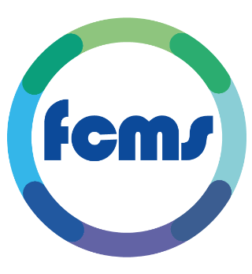

**FCMS (NW) Ltd JOB DESCRIPTION**

**Job Title: Sessional Dentists** to join our Rosters for Out of Hours Emergency Dental Service.

**Locations**: Blackburn – Barbara Castle Way - BB2 1AX

Burnley – St Peters Centre - BB11 2DL

Blackpool - Whitegate Drive Health Centre – FY3 9ES

Morecambe – Queen Victoria Centre – LA4 5NN

**Hours**: BANK

**Salary:** £63.07 - £73.93 an hour, Public Holiday Enhancements

**Overview:** Providing high-quality dental care has long been at the core of what we do at FCMS, and we have done so for over two decades. From our humble beginnings of operating in a single surgery in Blackpool, we’ve now expanded to delivering emergency OOH dental services 365 days a year, to more than 10,000 patients annually across the Fylde Coast, Morecambe Bay, Blackburn, and Burnley. Our dental services have also grown to include domiciliary dental care, and the Lancashire and South Cumbria Dental Helpline.

We are proud to have an enthusiastic team of dental nurses, receptionists and experienced leaders, all working hard to deliver the best possible dental care.

**Values:**

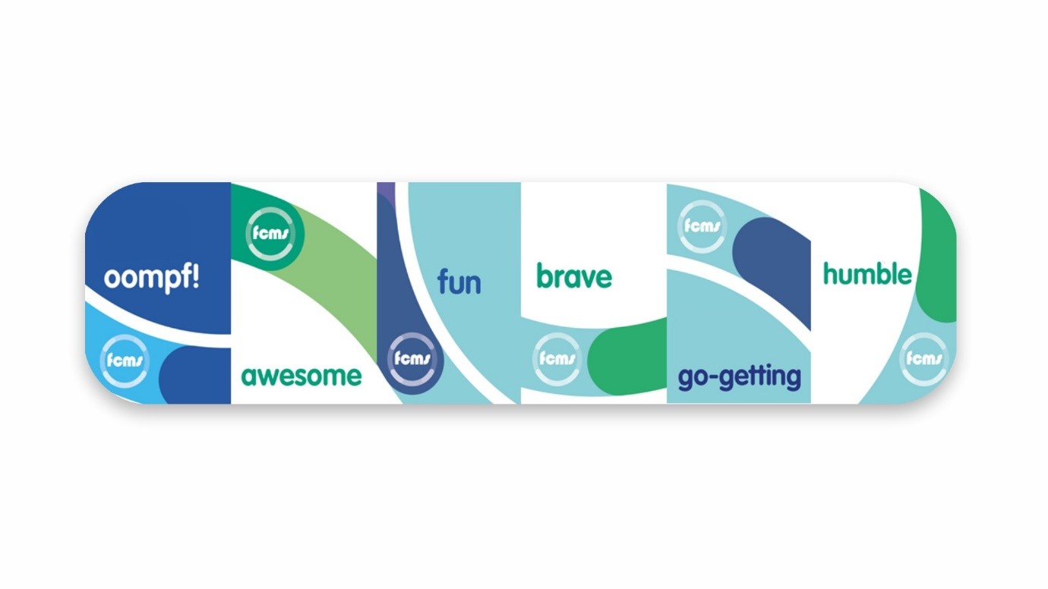

* **Fun: People rarely succeed unless they are having fun. Happiness is healthy!**
* **Awesome: We aren’t here to be average, we’re here to be awesome!**
* **Humble: We’re here to make a difference to the lives of others, NOT to see how important we can become**
* **Brave: We challenge the norm. We have the courage to get the difficult jobs done**
* **Oomph: We have natural oomph! It’s infectious!**
* **Go-getting: We are intuitive to changing needs and respond quickly which we do with energy, ideas, and positivity**

**Emergency Dental Services GDP Information**

**About FCMS**

At FCMS, we work hard, love what we do and are seriously focused on our patients and colleagues. We make a difference.

We have over 25 years of experience and expertise as a provider of Urgent Care Services. We work closely with colleagues and partners, constantly exploring innovative ways of working, to reduce pressures on health services across our communities and provide exceptional levels of care to patients. We are a forward-thinking, growing company, now operating in several areas including the Fylde coast, Lancashire, and Doncaster. In addition to providing urgent medical and dental care services, we support Primary Care services, operate call handling and diagnostic services, and are also involved in Complex Lives projects. These are just some of the amazing services we provide.

**About our dental team**

Providing high-quality dental care has long been at the core of what we do at FCMS, and we have done so for over two decades. From our humble beginnings of operating in a single surgery in Blackpool, we’ve now expanded to delivering emergency OOH dental services 365 days a year, to more than 10,000 patients annually across the Fylde Coast, Morecambe Bay, Blackburn, and Burnley. Our dental services have also grown to include domiciliary dental care, and the Lancashire and South Cumbria Dental Helpline.

We are proud to have an enthusiastic team of dental nurses, receptionists and experienced leaders, all working hard to deliver the best possible dental care.

**What will this involve for you as a supplier**?

* The service is not UDA driven!
* Immediate availability (subject to onboarding checks).
* Sole Trader or Ltd Company with direct invoicing.
* Shift availability is shown on a platform called RotaMaster. We publish our Rosters 1 month at a time, you select dates you wish to supply us with on here.
* Patients are initially triaged by the dental helpline. Where a urgent or emergency appointment is required, patients will be booked into their local EDS clinic.
* Patients attending our clinics will usually present with a range of urgent or emergency dental needs. A manageable number of patient slots will be made available. Whilst it is a busy service, we find with the experienced chairside support in place, teamworking and additional support by an on-call senior nurse during clinic hours, our service runs smoothly.
* We encourage definitive treatment wherever possible and expect clinicians to follow internal and external guidelines to ensure good practice. We pride ourselves on delivering a high standard of patient care.
* Due to the nature of our service and the cohort of patients seen, clinicians must have excellent communication and time-management skills. It’s fulfilling and an interesting type or work, suitable for ‘more experienced’ and also recently qualified clinicians.

Some clinicians who work privately in their 9 to 5 job supply us with sessions and see it as their way of giving back to the community/NHS.

We have self-employed opportunities for Dentists available at the following locations:

• Blackburn – Barbara Castle Way - BB2 1AX

• Burnley – St Peters Centre - BB11 2DL

• Blackpool - Whitegate Drive Health Centre – FY3 9ES (NOT AS MUCH AVAILBLE AT BLACKPOOL)

• Morecambe – Queen Victoria Centre – LA4 5NN

**Rate of pay & session times**– as per table.

|  |  |  |  |
| --- | --- | --- | --- |
| **Blackpool & Morecambe – weeknights** | | | |
| Monday to Thursday | 6:00pm | 9:30pm | £220.75 (£63.07ph) |
| Friday | 6:00pm | 9:30pm | £258.75 (£73.93ph) |
| **Blackburn & Burnley – weeknights** | | | |
| Monday to Thursday | 6:00pm | 9:00pm | £189.21 (£63.07ph) |
| Friday | 6:00pm | 9:00pm | £221.79 (£73.93ph) |
| **Blackburn, Burnley weekends** | | | |
| Saturday & Sunday | 2.30pm | 6pm | £258.75 (73.93ph) |
| **Morecambe weekends** | | | |
| Saturday & Sunday | 1.30pm | 5pm | £258.75 (73.93ph) |
| **Blackpool - weekends** | | | |
| Saturday full shift **OR** | 10.30am | 6pm | £517.51 (73.93ph) |
| Saturday split shift option | 10.30am until 2pm | 2.30pm until 6pm | £258.75 (73.93ph) for each shift. |
| Sunday (can offer split shift as above) | 10.30am | 6pm | As above |
| Sunday 2nd dentist | 2.30pm | 6pm | £258 (73.93ph) |

**What’s in it for you?**

Work alongside our friendly, experienced team, and have the autonomy of being self-employed, with no UDA requirements. Sessional opportunities allow you to pick and choose when and where you want to provide your services and enjoy the flexibility and sense of satisfaction with providing Out of Hours Emergency Dental Care to patients in need.

Our clinical governance committee meets regularly 6/52. We are innovative and are committed to continuously improving our service.

‘Brew’ facilities and parking at most sites.

If the above is talking to you! Then we’d love to hear from you! 😊

**Please contact our Dental Service Lead – Ms Jordan McCreedy on 07961 221266 or Jordan.McCreedy2@nhs.net**

Clinicians must be eligible to work in the UK, be GDC registered (without conditions or restrictions), have an active NHS performer number, have appropriate indemnity in place and an up-to-date enhanced DBS check.

**Person Specification**

|  |  |  |
| --- | --- | --- |
|  | **ESSENTIAL** | **DESIRABLE** |
| **Requirement** | Active NHS Performer  GDC Registered |  |